# **Problem Statement and Importance**

Agriculture is one of the most important sectors for the global economy, and early detection of plant diseases plays a crucial role in ensuring healthy crop production.

Manual identification of plant diseases is often inaccurate and time-consuming due to the similarity in symptoms among different diseases.

The system will assist farmers by providing quick and accurate diagnosis, allowing for timely intervention and treatment to prevent crop loss and improve productivity.

The objective of this project is to develop an AI-based Plant Disease Detection System capable of diagnosing various plant diseases from leaf images. By leveraging Convolutional Neural Networks (CNNs), the system will classify plant conditions into different categories (healthy or specific disease types).

This solution aims to:

* Support farmers with an easy-to-use diagnostic tool.
* Reduce dependency on manual observations and expert consultations.
* Enable early intervention to control the spread of diseases.
* Improve crop yield, reduce economic losses, and promote sustainable agricultural practices.

# **Pipeline**

### **1. Data Collection and Data Loading**

The development process for the Plant Disease Detection System follows the steps outlined below:

In this step, a dataset of plant leaf images is collected.  
 The dataset includes images of both healthy plants and plants affected by various diseases.

After collection, the dataset is divided into three parts:

* **Training Set**: Used to train the model.
* **Validation Set**: Used to tune the model during training.
* **Testing Set**: Used to evaluate the model after training.

Each part of the dataset is further organized into categories, where each category corresponds to a specific plant disease or healthy condition.  
This structured organization ensures that the model can learn to accurately identify and classify different diseases.

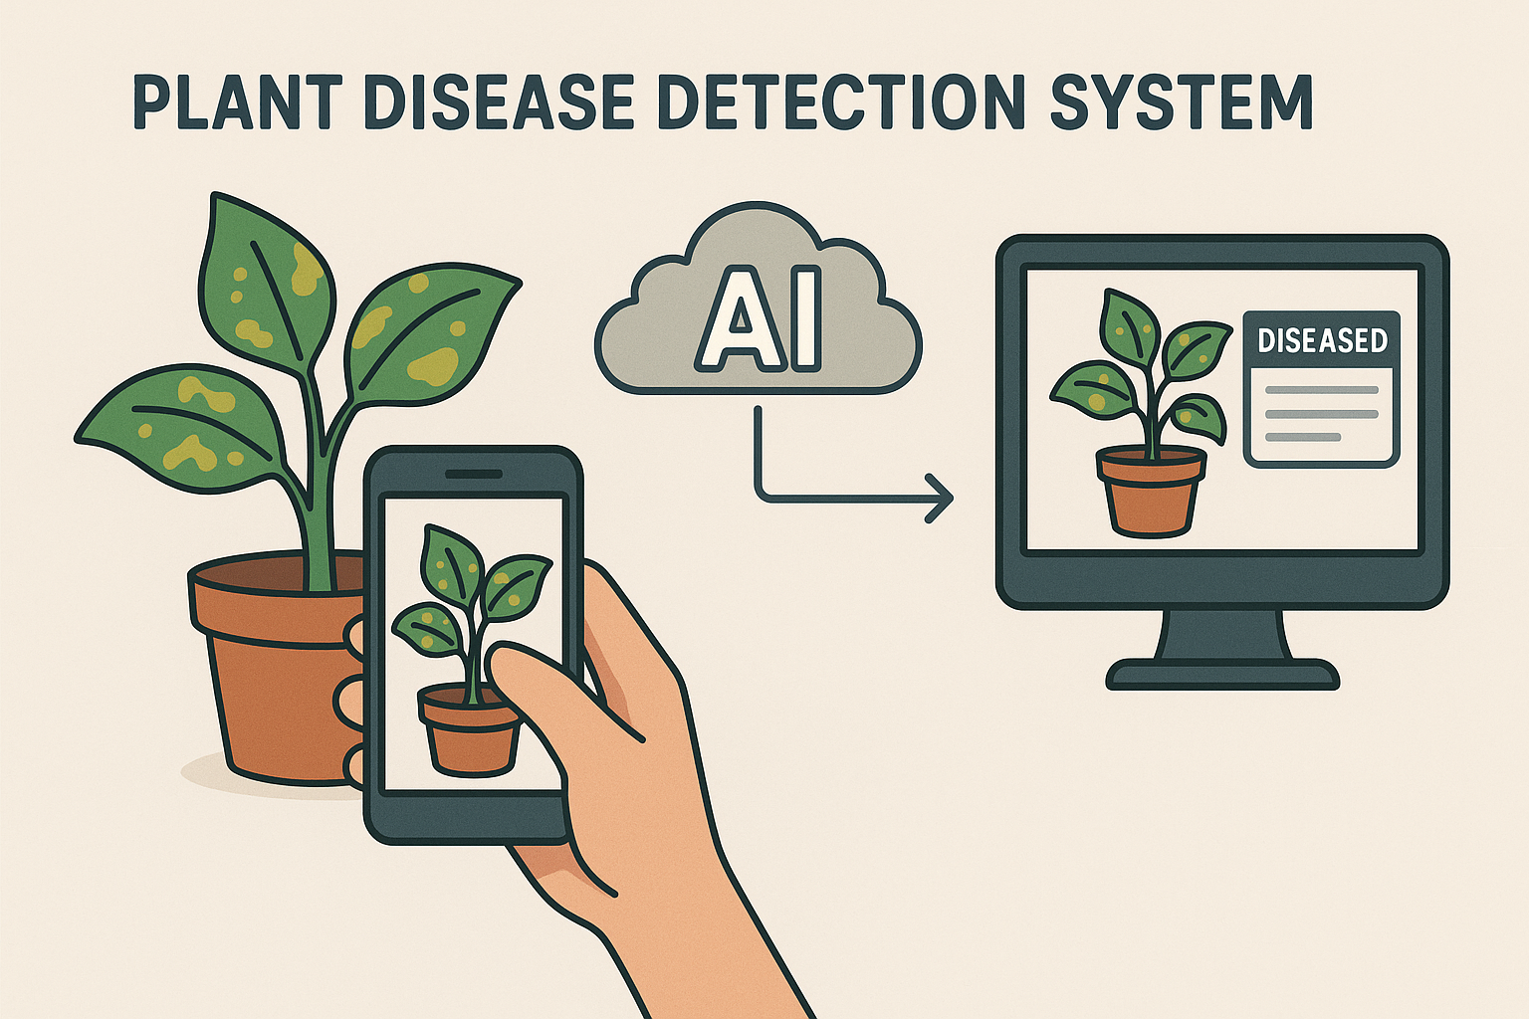

### **2. Dataset Preparation**

* The complete dataset, which includes both healthy and diseased plant leaf images, is first compressed into a ZIP file. This step helps reduce the overall file size and makes it easier to manage.
* The ZIP file is then uploaded to Google Drive, ensuring convenient cloud storage and easy access across different environments. Google Drive acts as a centralized location where the dataset can be accessed and shared if needed.
* To access the dataset from Google Colab, Python code is used to mount Google Drive. This allows seamless integration between Colab and Google Drive, providing direct access to the dataset stored in the cloud.
* Once mounted, the dataset is unzipped within the Colab environment using Python. This extraction process makes the dataset available for further preprocessing, model training, and evaluation. The unzipped dataset is organized into its respective training, validation, and testing subsets, ensuring that the model can be trained and evaluated effectively.

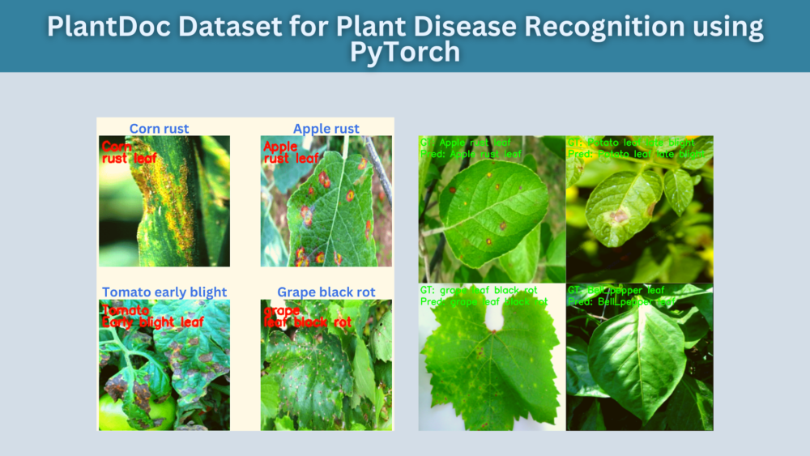

### **3. Image Processing and Image Augmentation**

To ensure uniformity and compatibility with the model, all images in the dataset are resized to a standard dimension. For instance, each image might be resized to 128×128 pixels. This step ensures that all images have the same size, which is important for feeding them into the neural network.

In addition to resizing, **image augmentation** techniques are applied to artificially expand the dataset and introduce diversity. These techniques include:

* **Rotation**: Rotating the image by random angles (e.g., 30° or 90°) to help the model become invariant to orientation.
* **Flipping**: Flipping the image horizontally or vertically to simulate different perspectives.
* **Zooming**: Randomly zooming into parts of the image to focus on specific features.
* **Shifting**: Shifting the image along the x or y axis to simulate slight variations in position.

These augmentation techniques not only help in increasing the dataset size but also introduce variations that help prevent overfitting and improve the model’s ability to generalize to new, unseen data.

Finally, the image preprocessing ensures that all images are standardized, making them suitable for input into the model. These steps enhance the model’s learning process by providing more diverse examples and making the data more consistent.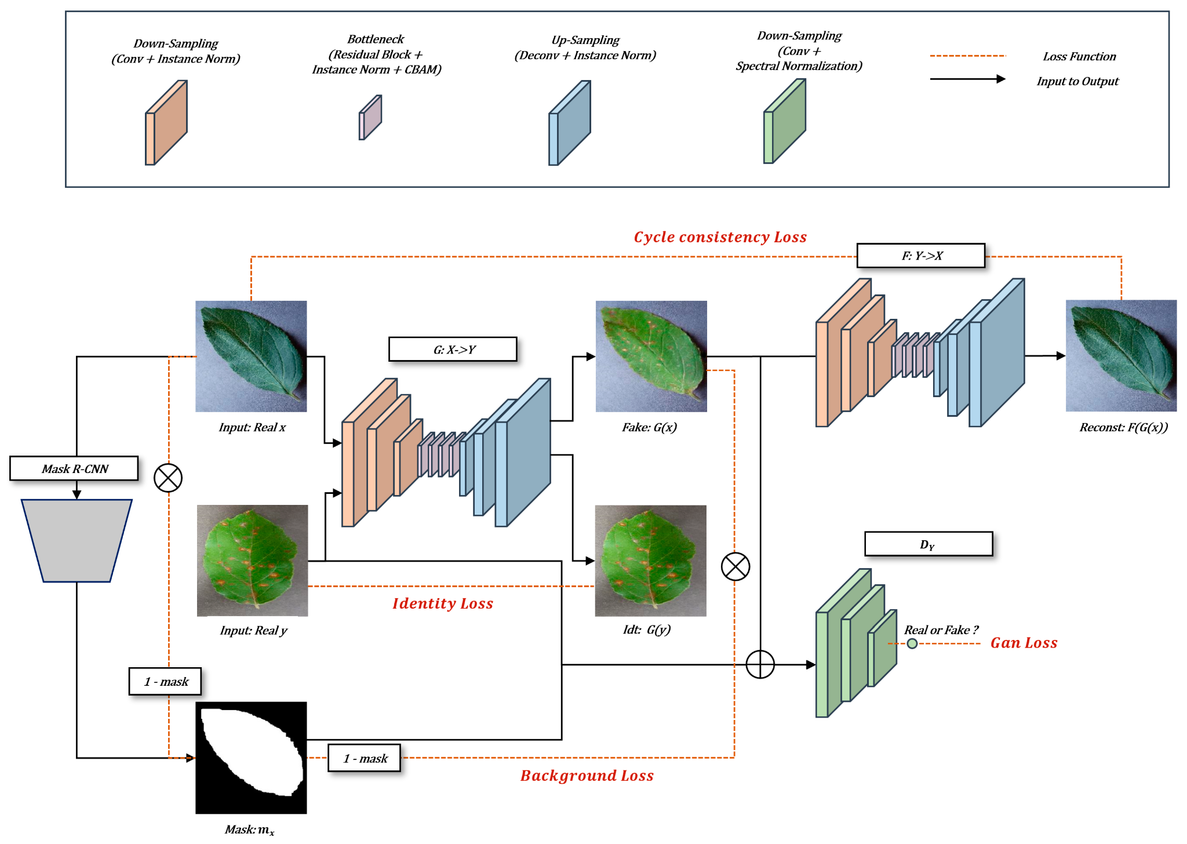

### **4. CNN Model Development**

* A Convolutional Neural Network (CNN) architecture is designed and implemented.
* The model is trained using the training dataset and validated using the validation dataset to optimize performance.

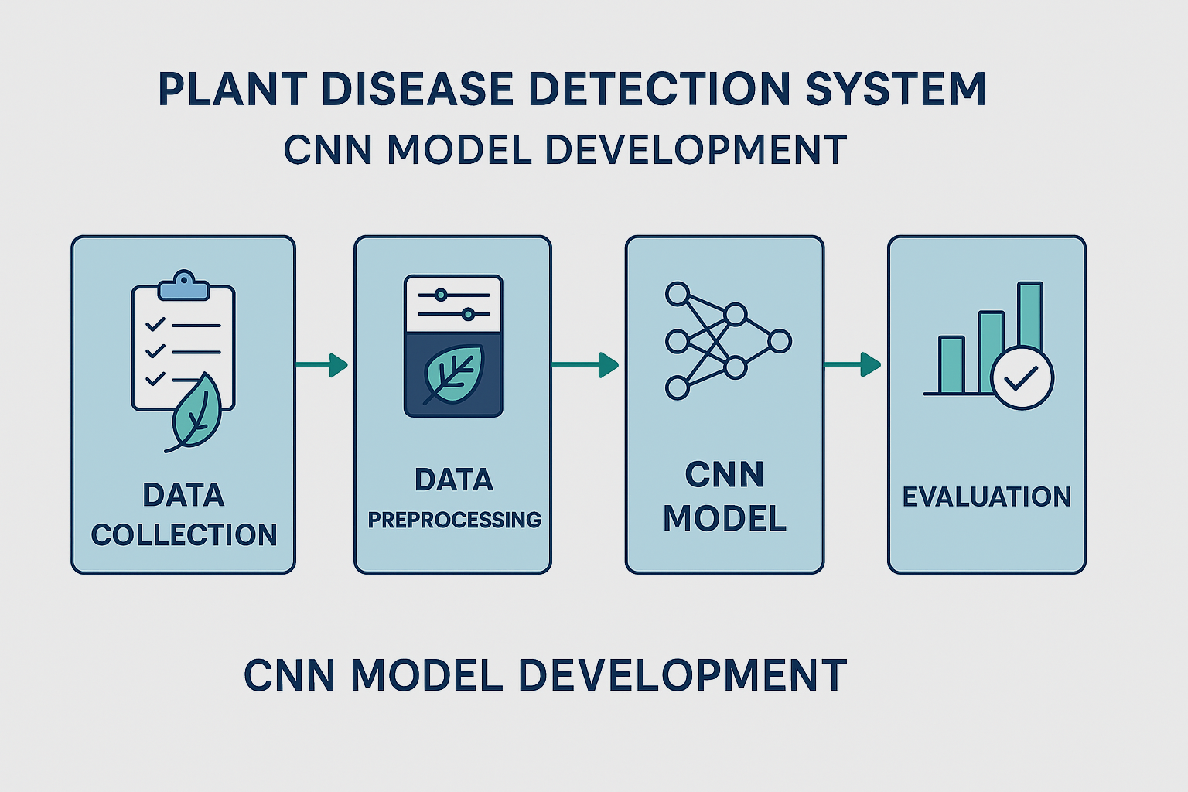

### 

### 

### 

### 

### 

### 

### **5. Testing and Evaluation**

* After training, the model is tested on the testing dataset.
* Performance metrics such as accuracy, precision, recall, and F1-score are calculated to evaluate the effectiveness of the model.

